*Heaven’s light is our guide.*

**Rajshahi University of Engineering and Technology**

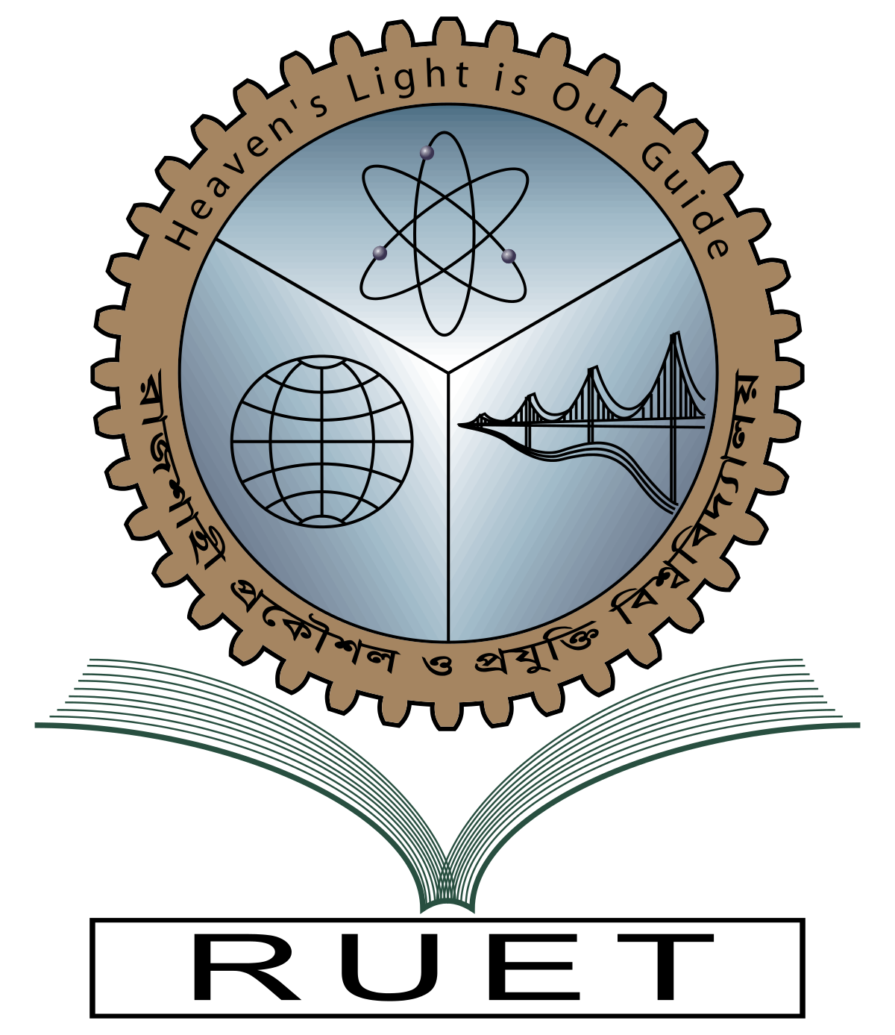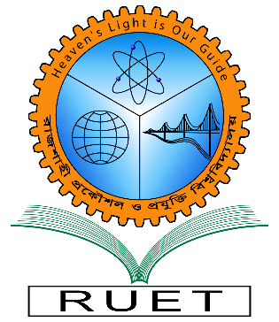

**Department of Electrical & Electronic Engineering**

**PROJECT**

**Course no.** EEE 4210

**Course title:** Embedded System Design Sessional

**Project Title:** Design and implementation of an induction motor drive system using Arduino Uno and single-phase H-Bridge inverter.

**Submitted to**

**Md. Razon Chowdhury**

**Assistant Professor**

Dept. of Electrical & Electronic Engineering,

**Rajshahi University of Engineering and Technology.**

**Submitted by**

**Ashraf Al- Khalique**

**Student ID:** 1801171

**Session:** 2018-2019

Dept. of Electrical & Electronic Engineering,

**Rajshahi University of Engineering and Technology.**